Pinkvilla App User Workflow: From Login to Article View

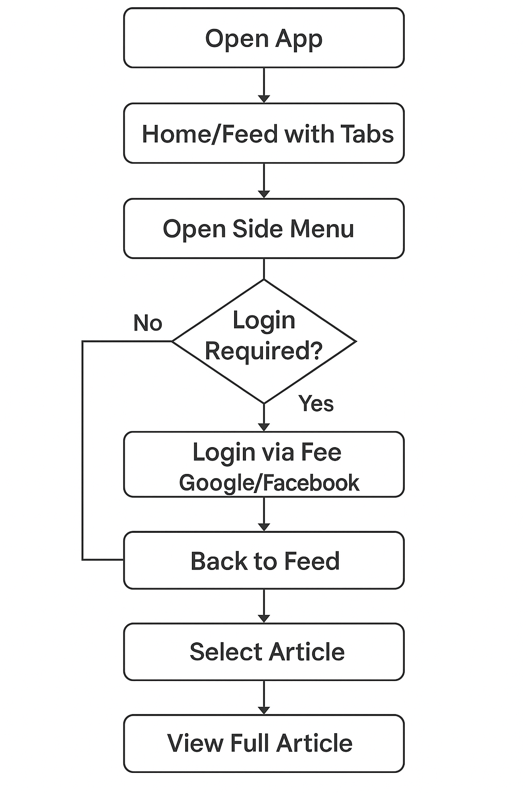

APP SCREENS:

Launch Screen Home/Article-listing Screen Side-menu
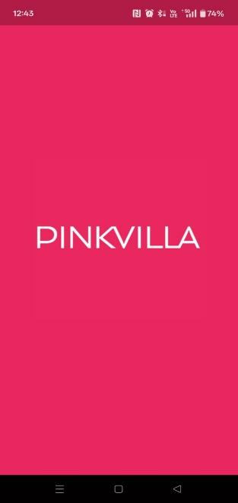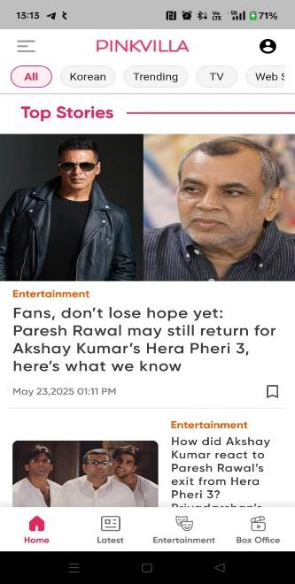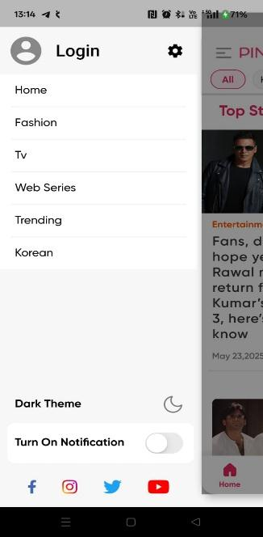

Login popup Article-detail Screen

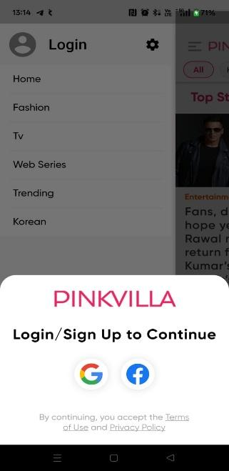

🟣 Step 1: Launch & Browse
- Action: User opens the Pinkvilla app.
- UI Observations:
  - The landing screen shows "Top Stories" and article previews with tabs like Korean, Trending, TV, and Web Series.
  - Bottom navigation bar includes: Home, Latest, Entertainment, Box Office.

🟣 Step 2: Open Side Menu
- Action: User taps the hamburger (☰) menu icon in the top-left.
- UI Observations:
  - A navigation drawer opens with categories: Home, Fashion, TV, Web Series, Trending, Korean.
  - Settings for Dark Mode and Notifications are available.
  - Social media links (Instagram, Twitter, YouTube) are visible.

🟣 Step 3: Attempt to Access Features Requiring Login
- Action: User taps on an option that requires authentication (e.g., liking, commenting, saving an article).
- UI Reaction: A Login/Sign Up modal appears.
  - Offers Google and Facebook login.
  - Terms of Use and Privacy Policy links are provided.

🟣 Step 4: Authentication
- Action: User selects either Google or Facebook to sign in.
- Backend: OAuth authentication is initiated and completed.
- Outcome: User is now logged in, and session is stored.

🟣 Step 5: Return to Content Feed
- Action: User navigates back to the home screen or a specific section like Trending or Korean via tab or drawer.
- UI: Articles are listed with thumbnails, headlines, timestamps, and categories.

🟣 Step 6: Select an Article
- Action: User taps on an article preview (e.g., Janhvi Kapoor’s Cannes debut).
- UI Reaction: Full article screen opens.

🟣 Step 7: Read Full Article
- UI Features:
  - Headline, author name, timestamp, and like/comment icons at the top.
  - Full body content with paragraph formatting and bolded headings.
  - Font size adjusters (A-, A+) at the bottom.
  - Share and bookmark icons available.

